**Name: ___**_________________

**Lab 2** (Due on Sunday noon)

In this lab, you **need to use MS Visio to create relational data models and use MS ACCESS to build the tables for the following two database problems.**

**Problem Description**

**Problem 1:** You are asked to design a database for Oswego new call center. Oswego members can make any number of phone calls to customer care representatives in the call center. Each call can be handled by only one customer care representative. Throughout the day each customer care representative will attend any number of calls assigned to him or her. All the customer care representative information is required. After each call, the Oswego member will give rate the customer care representative service to be either OK or KO. Depending on the status of the review from the member, the performance points (OK = 1, KO = 0) will be added to the customer care representative. Also, at the end of each month the variable pay will be calculated based on the performance points of each customer care representative. For example, the variable pay can be (the number of OKs/total number of calls handled by the employee) TIMES 0.5 TIMES the customer care representative’s base salary. This variable pay will then be added to Basic salary and the Total salary of the customer care representative will be established.

**Problem 2:** Create one ER diagram of a ternary relationship, e.g., doctors prescribes medicines for patients. But you can’t use this doctor example in your report, and you have to create a different one that is reasonable by yourself. In each entity, you can specify only the primary key and foreign key fields without defining other non-key fields. Establish the cardinality of the relationship between entities. You also want to show the ER diagram in Visio.

Hint: example- Doctor prescribes medicines for patients.

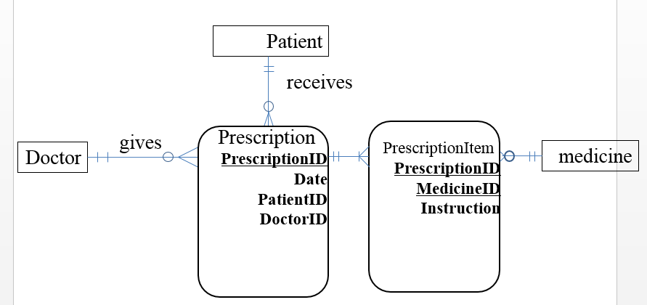

**Submission instruction**

Please submit your lab report (including the ERDs and screenshots) in **one** **PDF** file to BlackBoard. Name your file in this format “IST659-Lab2-Lastname-Firstname.pdf”. For each of the two problems, you need to include the following two sections.

1. Screenshots of your Visio ERD diagram.

(1) Create necessary entities, and give appropriate names to them.

(2) Add entity attributes. Make sure the attributes are at atomic level using good naming conventions (no composite **attribute**, no multi-value attribute).

(3) Set up primary key(s) for each entity.

(4) Establish relationships between entities. Give the relationships appropriate and recognize the associations (foreign keys).

(5) Mark correct cardinality of the relationships, and their cardinality constraints.

(6) Remember to declare **necessary assumptions** **(business rules)** for the entities, if they cannot be presented in your E-R diagram.

1. screenshots of your Access tables your report.

(1) datasheet view of each table

(2) data relationship model

**GRADING CRITERIA:**

* Appropriate Keys assigned (Primary Keys and Foreign Keys), Required and optional attributes 2pts -> 0.5 points will be deducted for every mistake made
* Correct cardinality according to the assumptions or given conditions 1pt -> 0.25pt will be deducted for every mistake made
* Datasheet view of tables in Access with data 0.5pt
* Data relationship model in Access 1pt
* Understandable font and clear ERD screenshot 0.5pt

**Total: 5pt**